Experiment Details

|  |  |
| --- | --- |
| Department Name | Civil and Environmental Engineering |
| Class | Second year |
| Semester | Third |
| Subject Name | Water Quality Monitoring Laboratory |
| Experiment No. | 01 |
| Experiment Name | Determination of pH |

Version History

|  |  |  |  |  |
| --- | --- | --- | --- | --- |
| Sr. No. | Version Number | Created By | Approved By | Date |
| 1 | v1.1 | Saie Dhavale | Sourabh Joshi | 09/10/2020 |
|  |  |  |  |  |

AIM:

To determine the pH of given water sample

THEORY:

The pH of solution is negative common logarithm of the hydrogen ion activity.

The dilute solutions the hydrogen ion activity is at approximately equal to the hydrogen ion concentration. The pH of water measure is acid-base equilibrium and, in most natural waters, is controlled by carbon dioxide-bicarbonate-carbonate equilibrium system. An increased carbon dioxide concentration with their for lower pH, where as a decrease will cause it to rise temperature will also affect the equilibria and the pH. In pure water, a decrease in pH of about 0.45 occurs as the temperature is raised by 25 degree Celsius. In water with a buffer capacity imparted bicarbonate, carbonate and hydroxyl ions, this temperature effect is modified.

The pH of most raw water lies within the range 6.5 to 8.5

The pH of an aqueous sample is usually measured electromatically with the glass electrode. The temperature has a significant effect on pH measurement.

PRE TEST:

1. A solution with pH 10 is :
   1. Acidic
   2. **Basic**
   3. Neutral
   4. None of the above
2. Full form of pH is
   1. Power of hydrogen
   2. Potential of hydrogen
   3. **Both a) and b)**
   4. None of the above
3. pH of neutral water is:
   1. 7
   2. Negative logarithm of 1x ${10}^{-7}$
   3. 1x ${10}^{-7}M$
   4. **All of the above**
4. Which of the following is relation between the concentration of hydrogen and hydroxyl ions in the acidic solution?
   1. **Value of hydrogen ion concentration is Greater**
   2. Value of Hydroxide Ion concentration is Greater
   3. Both always the same
   4. The concentration keeps changing
5. The measurement of hydrogen ion concentration can be made by measuring the potential developed In an electrochemical cell
   1. **True**
   2. False

PROCEDURE:

1.Set temperature Of pH meter.

2.Wash, Clean and dry the PH electrode,

3. Immerse glass electrode in the buffer solution of known pH and calibrate meter.

4.Remove electrode, wash with distilled water and clean with filter paper.

5.Immerse electrode in the water sample and record pH.

6.Repeat the procedure for other water samples.

OBSERVATION TABLE:

|  |  |  |
| --- | --- | --- |
| Sr. No. | pH reading | |
|  | pH paper | pH meter |
| Sample no. 1 |  |  |
| Sample no. 2 |  |  |
| Sample no. 3 |  |  |

RESULT:

pH of given samples tested is in the range of …………...

POST TEST:

1. The composition of Glass membrane in glass electrode cannot have which of the following
   1. Sodium silicate
   2. Calcium silicate
   3. Lithium silicate
   4. **Barium silicate**
2. 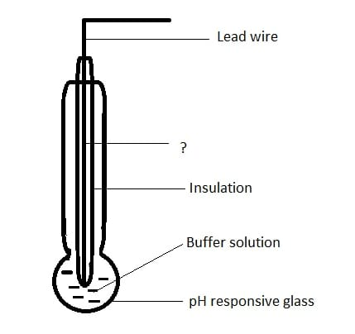Identify the unmarked component
   1. Platinum leads
   2. **Silver wire coated with silver chlorides**
   3. Copper wire
   4. Platinum reference electrode
3. Which of the following cannot be a failure in pH metres
   1. Defective electrodes
   2. Deffective input circuitry
   3. Defective electronic circuitry
   4. **Defective calibration**
4. Which of the following can be used to provide automatic temperature compensation
   1. **Thermistor**
   2. Thermometer
   3. Calibration of different temperature
   4. Proper insulation
5. The electrodes used in pH measurement have which of the following internal resistance
   1. Very low resistance
   2. **Very high resistance**
   3. Moderate resistance
   4. No resistance

REFERENCE:

As per environmental Hygiene Committee recommendation, acceptable range of pH for drinking water is between 7.0 to 8.5